WQD 7001 Principles of Data Science

A Deep Dive on Asian Air Quality Index and Future Trend

Group 13 Assignment

Members | Role | Matric Number
CHEN HUILIN | Group Leader / Detective | 23113750
LOONG SHIH-WAI | Detective | 24059242
QIU YIMEI | Maker | 23052209
WANG SHIBO | Maker | 23111363
ZHANG YANWEI | Oracle / Secretary | 22102113

Table of Contents

1 Project Background & Objectives 3
1.1 Project Background 3
1.2 Project Objectives 3
2 Data Acquisition, Scrubbing and Exploration 4
2.1 Data Acquisition 4
2.2 Data Scrubbing 4
2.3 Data Exploration 4
3 Data Modelling 6
3.1 Evaluation Metrics Interpretation 6
3.2 SARIMA Model 6
3.2.1 Objective 6
3.2.2 Methodology 6
3.2.3 Model performance evaluation 7
3.3 SARIMAX Model 8
3.3.1 Objective 8
3.3.2 Methodology 8
3.3.3 Model performance evaluation 8
3.4 Future DAQI Prediction 9
4 Data Interpretation 11
5 Plan for Reproducible Research 13
5.1 Code and Data Availability 13
5.2 Version Control 13
5.3 Documentation 13
5.4 Public Deployment 14
5.5 Reproducible Workflow 14
5.6 Data Accessibility 14
5.7 Open-Source Tools 14
6 Deployment of Data Product 15
6.1 Prepare GitHub Repository 15
6.2 Deploy Application Online 15
6.3 Post-Deployment Maintenance. 16
7 Insights and Conclusion 17
8 References 18

Project Background & Objectives

Project Background
This project focuses on cleaning and analysing air quality data from selected countries in Asia, with the primary goal of developing a platform to predict and visualise the Daily Air Quality Index (DAQI) for various cities. The platform aims to provide actionable insights and decision-making support for policymakers, urban planners, researchers, and organisations like UNEP, WHO, Greenpeace, and Clean Air Asia, enabling effective air quality management and pollution mitigation.
Key users include policymakers seeking reliable data for clean air policies, researchers analysing pollution trends and health impacts, and the public accessing real-time air quality data to raise awareness. Tech companies involved in pollution monitoring and forecasting are also target users.
The project offers several benefits: ensuring data quality through robust cleaning and processing, supporting policy development by identifying pollution hotspots, raising public environmental awareness, and fostering innovation in pollution monitoring technologies. By integrating advanced machine learning algorithms, the platform will predict DAQI trends and pollutant levels, providing 30-day forecasts and actionable insights.

Project Objectives
To investigate the correlation between Air quality index and different pollutants.
Analyze the relationship between AQI and pollutants (PM_{2.5}, PM₁₀, NO₂, O₃, and SO₂). To identify key factors influencing air quality and pollution trends.
To generate future air quality prediction model based on existing data set.
Build machine learning models to forecast 1-year DAQI trends and pollutant levels, providing actionable insights for proactive air quality management.
To provide insights to policymakers on actionable improvement actions。
Provide tools and data-driven insights for policymakers, researchers, and stakeholders to support informed decisions and improve air quality effectively.

Data Acquisition, Scrubbing and Exploration

Data Acquisition
Dataset is obtained from the open-source platform, Kaggle. The dataset title is ‘World Weather Repository (Daily Updating)’ published by Nidula Elgiriyewithana. It is updated daily and the version of dataset that was used for this project is version 397 and version 220.

Data Scrubbing
Dataset obtained is scrubbed to remove unnecessary information and only retain the data useful for this project:
- Weather data information unrelated to air quality analysis is dropped.
- Data points from out of Asia region is dropped.
- Check for any null or blank values within the dataset.
- Further removal of data points with insufficient entries.
- Standardise the date range of which data exists for each country – effectively standardising dates for each country and location to be between August 29th, 2023, to November 3rd, 2024, only.

Data Exploration
After scrubbing through the data, exploration is performed to the data to extract some initial understandings from the data.
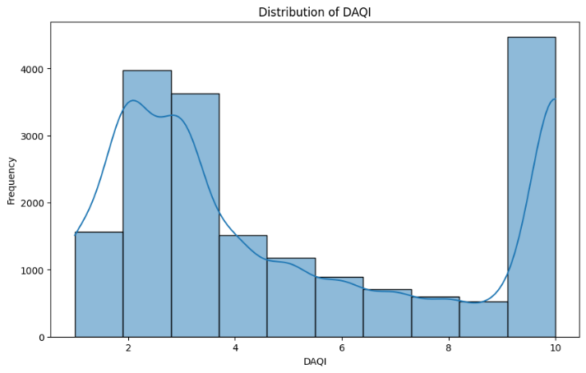
Figure 1 Distribution of DAQI values in the dataset
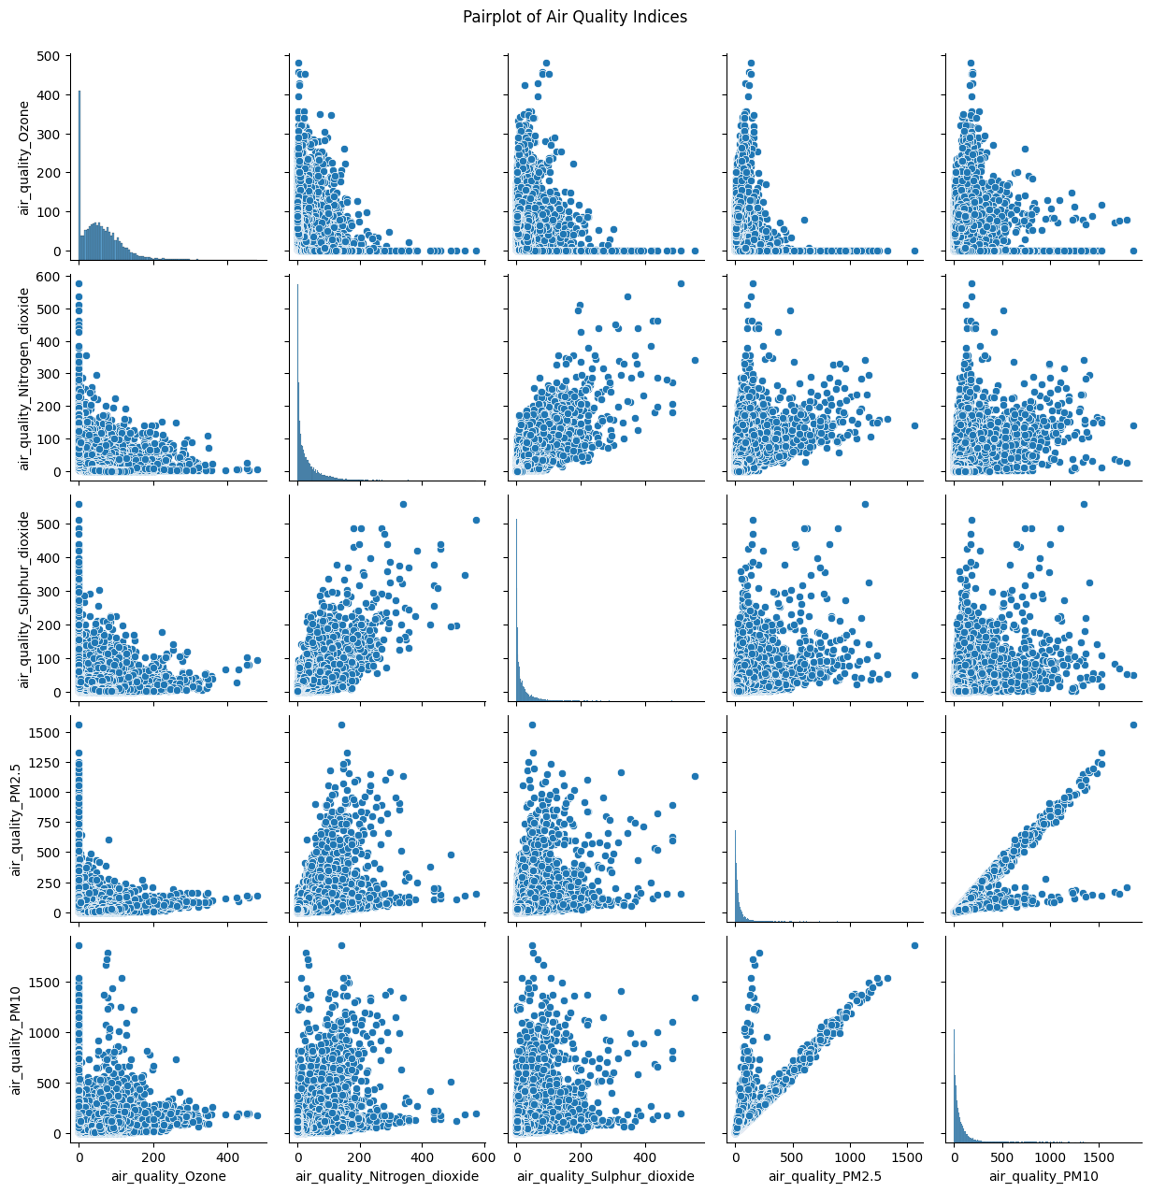
Figure 2 Pairplot of Air Quality Indices
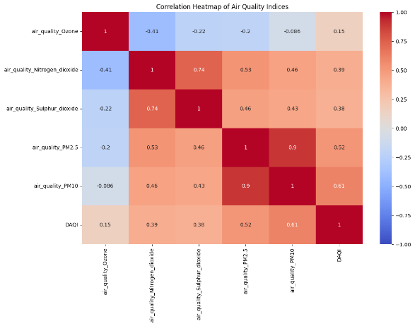
Figure 3 Correlation Heatmap of Air Quality Indices

From the data exploration, we can see that the DAQI is strongly correlated with its components such as PM2.5 and PM10 contaminants present in the air. Also, we learnt that both PM2.5 and PM10 contaminants, and sulphur dioxide and nitrogen dioxide contaminants are strongly correlated with each other which will help policymakers come up with a more effective policy to curb air pollution and promote a healthier environment for citizens.

Data Modelling
This section details the modelling process used to forecast future AQI values and compare performance of different models. Two key models, SARIMAX and Prophet were applied in a hybrid approach to enhance prediction accuracy.

Evaluation Metrics Interpretation
Mean Absolute Error (MAE):
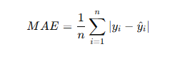
Interpretation: Measures the average magnitude of errors between predicted values and actual values.
Mean Squared Error (MSE):
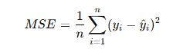
Interpretation: Penalises larger errors more than smaller ones due to squaring the error term.
Root Mean Squared Error (RMSE):
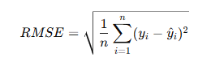
Interpretation: Square root of the MSE, providing error values in the same unit as the target variable

SARIMA Model
The Seasonal Auto-Regressive Integrated Moving Average (SARIMA) model is an extension of the ARIMA model that incorporates seasonality into time series forecasting. This section details the implementation of the SARIMA model for single-variable AQI forecasting, focusing on modelling the DAQI index for a selected country.

Objective
- Forecast future DAQI values for the selected country using a univariate SARIMA model.
- Identify patterns and seasonal trends in historical AQI data to generate reliable predictions for air quality management.

Methodology
Country Selection:
Filtered the dataset to include data specific to the selected country (e.g., Iran).
Data Splitting:
Training Data: Data up to and including 31/8/2024.
Test Data: Data after 31/8/2024.
Standardisation:
Standardised the DAQI values using StandardScaler to ensure numerical stability and improve model performance. The training data was used to fit the scaler, which was then applied to both training and test data.
Model Specification:
SARIMA parameters: (1,1,1) × (1,1,1,12)
Evaluation:
Performance was assessed using metrics such as MAE, MSE, and RMSE to quantify forecast accuracy.

Model performance evaluation

Example Country: Iran

Visualisation
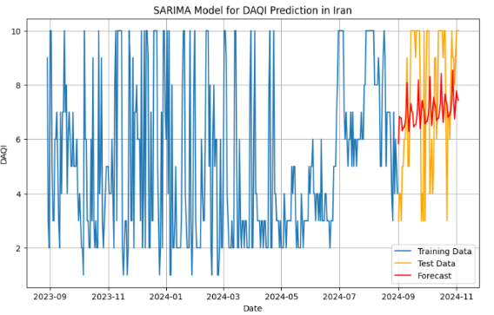
Figure 4 DAQI Visualisation for Iran with predicted values.

Model Performance Metrics

Mean Absolute Error (MAE) 2.1903480488805216
Mean Squared Error (MSE): 6.10505340799592
Root Mean Squared Error (RMSE): 2.470840627801785

Observation
The SARIMA model showed moderate performance for both Iran. The model achieved an MAE of 2.19, but the visualisation indicates that it failed to capture sharp AQI fluctuations, smoothing out variability in the test data. It highlights the SARIMA model's limitations in handling dynamic and non-linear trends, relying solely on historical AQI data without incorporating external factors.

Model Limitations
- Inability to Predict Irregular Patterns
AQI is influenced by dynamic and irregular factors, such as weather conditions, traffic patterns, and industrial activities, which cannot be captured by a simple univariate model
- High Error Values in Test Sets
Single-variable SARIMA does not account for the multivariate nature of AQI, which is influenced by pollutants (e.g., PM2.5, PM10), meteorological factors (e.g., temperature, wind), and human activities.

SARIMAX Model
The SARIMA model was extended to a SARIMAX framework to incorporate exogenous variables, allowing for improved AQI predictions by considering additional influencing factors. This section details its implementation and results.

Objective
Predict future AQI values for each country using a multivariate time series approach that accounts for the impact of external factors (e.g., air pollutants).

Methodology
Similar with SARIMA but add Exogenous Variables:
The target variable for prediction was DAQI (Daily Air Quality Index).
Exogenous variables included pollutant levels such as PM2.5, PM10, Ozone, Nitrogen Dioxide, and Sulphur Dioxide.

Model performance evaluation

Example Country: Iran

Visualisation
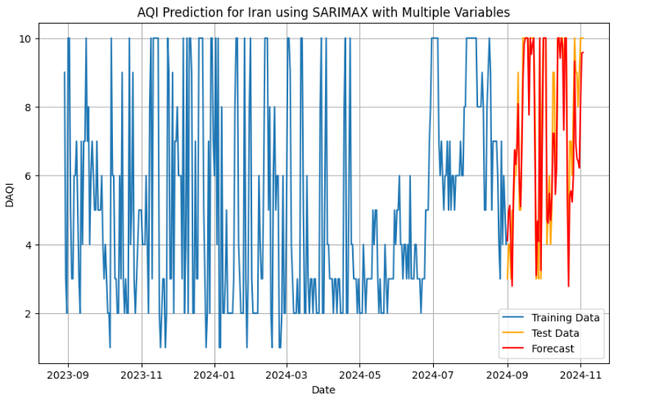
Figure 5 AQI prediction for Iran using SARIMAX with multiple variables.

Model Performance Metrics
Mean Absolute Error (MAE): 0.7313090408735258
Mean Squared Error (MSE): 1.0295556496908054
Root Mean Squared Error (RMSE): 1.0146702172089241

Observation
The SARIMAX model demonstrated excellent performance for Iran with MAE of 0.73, MSE of 1.03. The inclusion of exogenous variables allowed the model to capture key trends and fluctuations in AQI effectively, as evidenced by the close alignment of predictions with the test data.
- Error Reduction:
For Iran, the MAE, MSE and RMSE dropped from 2.47 to 1.05, 6.10 to 1.09, 2.47 to 1.01 respectively.
- Improved Forecasting:
  - SARIMAX demonstrated a much better ability to capture dynamic changes and seasonal patterns in AQI.
  - The inclusion of exogenous variables allowed the model to account for additional influences (e.g., pollutant levels), enhancing predictive accuracy.
- Visualisation Comparison:
  - SARIMA forecasts showed over-smoothed predictions with poor alignment to sharp fluctuations in the test data.
  - SARIMAX forecasts, on the other hand, aligned closely with the test data for both countries, showing improved responsiveness to sudden changes.

Future DAQI Prediction
This section details the methodology and results for forecasting future DAQI values using a two-step process involving Prophet for exogenous variable forecasting and SARIMAX for DAQI prediction.
Step 1: Exogenous Variable Forecasting with Prophet
Objective:
Predict key air quality drivers, such as PM2.5, PM10, Ozone, Nitrogen Dioxide, and Sulphur Dioxide, for each country. Predict pollutant levels for the next year.
Adjustments:
Applied noise and sinusoidal fluctuations to account for real-world variability.
Clipped negative values to ensure physical feasibility of pollutant levels.
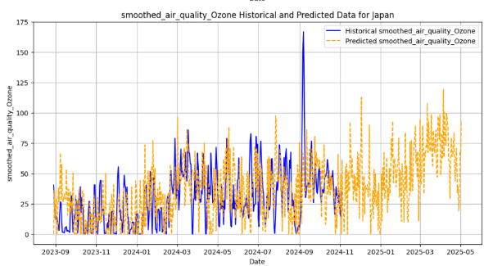
Figure 6 Ozone trend for Japan.
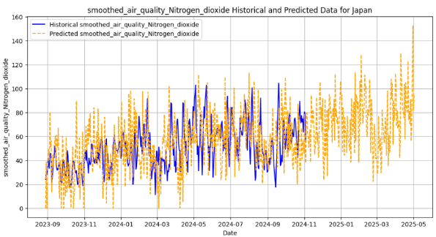
Figure 7 Nitrogen dioxide trend for Japan.
Step 2: DAQI Prediction with SARIMAX
Model Configuration:
Incorporated predicted exogenous variables (PM2.5, PM10, Ozone, etc.) to model their influence on DAQI.
Prediction Result (e.g. Mongolia)
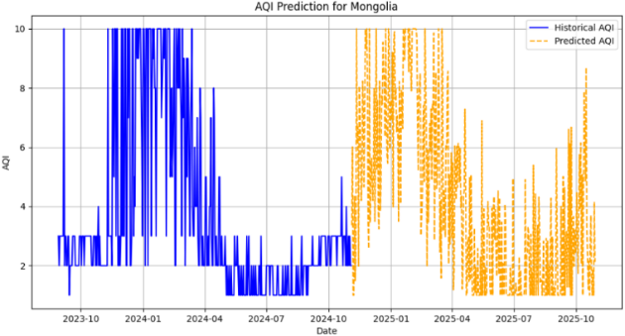
Figure 8 AQI Prediction for Mongolia

Data Interpretation
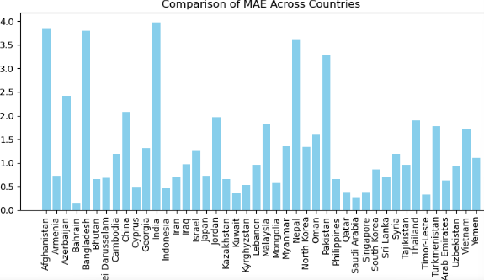
Figure 9 MAE comparison across countries.
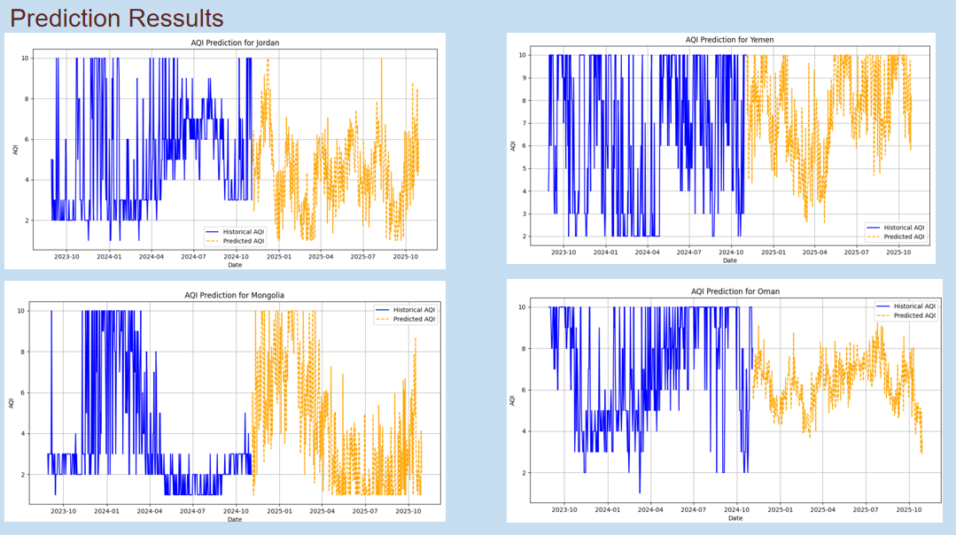
Figure 10 AQI Prediction for four countries.

From the AQI forecasting results across multiple countries, it is evident that the model's performance varies between nations. For those countries which show lower prediction errors (e.g. Mongolia, Japan), they have clear seasonal trends in air quality, such as winter pollution peaks with high-quality predictions of exogenous variables (e.g., PM2.5, PM10) that accurately captured AQI drivers. However, some countries exhibited higher prediction errors (e.g. India and Nepal), with MAE values exceeding 2.5. That’s because AQI is influenced by complex and dynamic factors (e.g., industrial emissions, traffic activity) that are not fully captured by the model and also caused by too many significant short-term fluctuations and lack of clear seasonal patterns.
Overall Trends: For most countries, MAE falls within the range of 0.5 to 2.0, suggesting that the SARIMAX model performs well in most cases. However, for countries with greater variability or insufficient exogenous variables, there is room for improvement in the model's performance.
Improvement Plan:
- Introduce additional dynamic variables, such as real-time weather data and social activity patterns, to improve prediction accuracy.
- Develop hybrid models that integrate SARIMAX with non-linear approaches, such as machine learning models, to better capture sudden pollution spikes.
- Enhance the quality and availability of exogenous variables, ensuring they are more reflective of the underlying drivers of AQI.

Plan for Reproducible Research
To ensure the reproducibility of this project, several measures have been implemented:
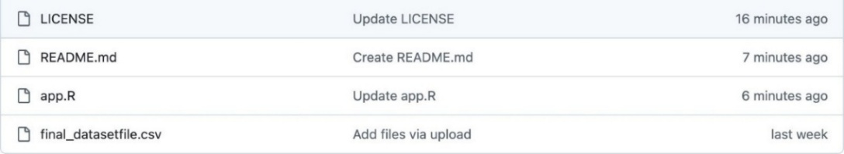
Figure 11 GitHub project interface

Code and Data Availability
The source code for the project, along with all relevant documentation, is hosted on a public GitHub repository. This repository includes the scripts used for data preprocessing, analysis, and visualisation, enabling other researchers to replicate the workflow. (https://github.com/sayuleri/shiny-air-quality-app ）

Version Control
GitHub is used for version control to track changes in the code and maintain a history of updates. This ensures transparency in the development process and facilitates collaboration.

Documentation
Comprehensive documentation is provided within the GitHub repository, including a detailed README file. The README outlines the project objectives, installation steps, dependencies, and instructions for running the Shiny app locally.(https://github.com/sayuleri/shiny-air-quality-app/blob/main/README.md)
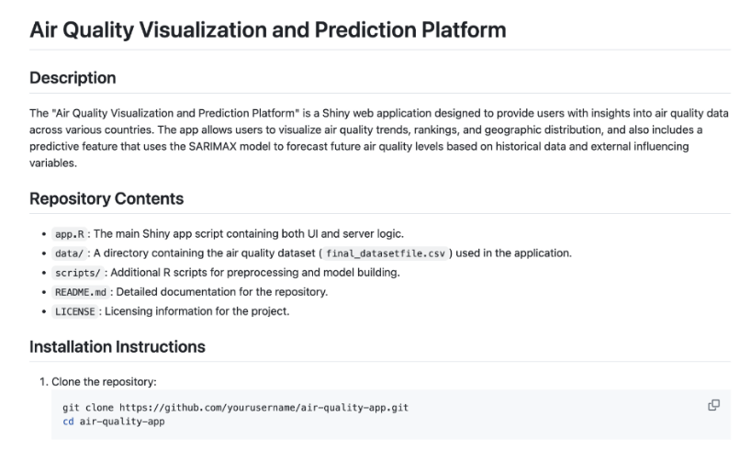
Figure 12 GitHub project readme

Public Deployment
The interactive Shiny web application is deployed on ShinyApps.io, making it accessible to anyone with an internet connection. This deployment ensures that users can explore the visualisations and analyses without needing to install any software locally.
(https://github.com/sayuleri/shiny-air-quality-app）
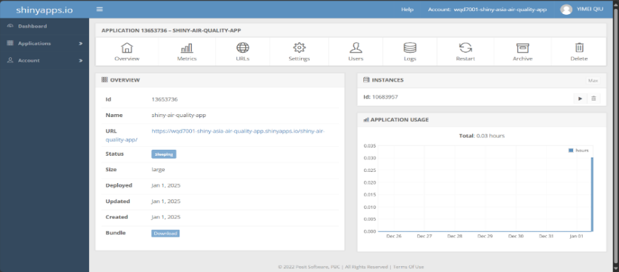
Figure 13 shinyapps.io deployment interface

Reproducible Workflow
The analysis pipeline is designed to be fully reproducible, with scripts structured to run end-to-end without manual intervention. This includes automated data import, cleaning, modelling, and visualisation steps.
(https://github.com/sayuleri/shiny-air-quality-app/blob/main/final_datasetfile.csv)

Data Accessibility
Publicly available datasets used in the project are clearly cited, and instructions for accessing the data are provided. Any proprietary data is replaced with simulated or anonymised datasets to allow reproducibility while respecting confidentiality agreements.
(https://www.kaggle.com/datasets/nelgiriyewithana/global-weather-repository?resource=download)

Open-Source Tools
This project exclusively uses open-source tools, including Python and R, ensuring reproducibility without proprietary software. Key R libraries include shiny, ggplot2, dplyr, and leaflet, while Python libraries like pandas, matplotlib, and seaborn are employed. The use of shiny and shinyapp.io enhances accessibility for interactive applications. By adopting open-source resources, the project promotes transparency, ensures reproducibility, and empowers the community to validate and expand its findings.

Deployment of Data Product

Prepare GitHub Repository
- Create a GitHub Repository:
Log in to GitHub, create a new repository, and set it to Public or Private.
Name: `shiny-air-quality-app`.
- Set up Locally:
mkdir shiny-air-quality-app
cd shiny-air-quality-app
Add app.R and `final_datasetfile.csv` to this folder.
- Push to GitHub:
git init
git add .
git commit -m "Initial commit for Shiny app"
git branch -M main
git remote add origin https://raw.githubusercontent.com/sayuleri/shiny-air-quality-app/main/final_datasetfile.csv
git push -u origin main

Deploy Application Online
- Install and configure ‘rsconnect’:
Install the package (R):
install.packages("rsconnect")
library(rsconnect)
- Set up your ShinyApps.io account (R):
rsconnect::setAccountInfo(name='wqd7001-shiny-asia-air-quality-app',
token='0D8468C90313D9128988F79C6B676137',
secret='secret')
- Deploy the Application:
Ensure `app.R` and `final_datasetfile.csv` are in the same folder.
Run the deployment command in R:
rsconnect::deployApp("~/shiny-app/")

- Access the Application:
After deployment, ShinyApps.io provides a URL:
https://WQD7001_shiny_Asia_air_quality.io/app-name/

Post-Deployment Maintenance.
- Manage Data Files:
Use relative paths to access data (R):
github_url <- "https://raw.githubusercontent.com/sayuleri/shiny-air-quality-app/main/final_datasetfile.csv"
data <- read.csv(github_url)
- Monitor Logs:
Debug and check performance via ShinyApps.io’s Logs feature.
- Update Applications:
Redeploy when changes are made (R):
rsconnect::deployApp("~/shiny-app/")
Push updates to GitHub:
git add .
git commit -m "Updated app features"
git push origin main

Insights and Conclusion
The modelling process demonstrated the effectiveness of time series models in forecasting AQI values across multiple countries. The SARIMA model performed moderately well for capturing seasonal trends but struggled with dynamic fluctuations due to its reliance on univariate data. By extending to the SARIMAX framework and incorporating exogenous variables like PM2.5, PM10, and Ozone, the prediction accuracy improved significantly, as shown by reduced error metrics and better alignment with real-world test data. However, the performance varied across countries, with better results in regions with clear seasonal patterns (e.g., Mongolia, Japan) and higher errors in countries influenced by complex, short-term factors (e.g., India, Philippines). Overall, this highlights the need for more dynamic variables, enhanced data quality, and hybrid approaches to further improve AQI forecasting, making it a valuable tool for air quality management and policy planning.
The results from our Air quality index forecast model indicate a consistent and concerning trend: prediction shows a pessimistic outcome for future air quality. Majority of countries in Asia Pacific will still be exposed to air pollution levels that pose a significant risk to their health. This situation will improve in most East Asian and South Asian countries, with air quality indices fluctuating and declining in the coming months, likely due to policy measures to control emission sources that are growing rapidly with economic development, including large industrial sources, power plants, and road transport.
In contrast, most Middle Eastern countries will remain at high DAQI, with desert climate, fossil fuel combustion, and the oil industry being the main potential sources.
While the models serve as a valuable tool for understanding air quality index trajectories, they also emphasise the urgent need for robust, actionable strategies to alter this path. Future iterations of the model could benefit from incorporating more varied data from atmospheric science and several fields, yielding more grounded results.

References

- DEFRA. (n.d.). UK Air Quality Annual Report. Department for Environment, Food & Rural Affairs (DEFRA). Retrieved from https://uk-air.defra.gov.uk/library/annualreport/index
- Huang, Y., Zhang, J., & Sun, Y. (2024). Analysis of AQI and its impacts. Environmental Toxicology and Pharmacology, 58, 18–29. https://doi.org/10.1007/s40201-024-00900-6
- Liu, J., & Zhang, Z. (2020). Air quality monitoring using IoT technologies. IEEE Access, 8, 12345–12356. https://doi.org/10.1109/ACCESS.2020.2993478
- Manchanda, R., & Sharma, M. (2024). Air pollution control technologies. Science of the Total Environment, 730, 138320. https://doi.org/10.1016/j.scitotenv.2020.138320
- Aeroqual. (2024). Understanding Air Quality Index (AQI). Aeroqual. Retrieved from https://www.aeroqual.com/blog/air-quality-index
- Zhang, L., & Xu, W. (2024). Air pollution control in industrial sectors. Journal of Environmental Management, 275, 111314. https://doi.org/10.1016/j.jenvman.2020.111314
- Gupta, R., & Singh, P. (2024). Effects of urban traffic on air quality in metropolitan cities. Science of the Total Environment, 731, 138127. https://doi.org/10.1016/j.scitotenv.2020.138127
- Wang, Y., & Li, F. (2024). Air pollution control strategies in agricultural areas. Environmental Pollution, 265, 114385. https://doi.org/10.1016/j.envpol.2020.114385
- Zhang, L., & Yu, S. (2024). Reducing air pollution from vehicle emissions. Science of the Total Environment, 730, 138320. https://doi.org/10.1016/j.scitotenv.2020.138320
- Wang, J., & Li, X. (2024). Evaluation of air quality in urban areas. Environmental Toxicology and Pharmacology, 56, 24–34. https://doi.org/10.1016/j.etap.2020.110213

